🏥 Automation Report
Organization: HealthCare Hospital & Diagnostics
🔷 Objective:
The purpose of this report is to outline which operational processes have been successfully automated by HealthCare Hospital & Diagnostics and which processes remain manual (non-automated). Additionally, the report includes proposed automation frameworks for the remaining manual processes to support future automation efforts, including flowchart-ready statements.
✅ Automated Processes
1. Appointment Booking Automation
Process Statement:
When a patient requests an appointment, the system checks both doctor availability and time slot availability.
If both are available, the appointment is confirmed.
If either the doctor or the time slot is unavailable, the system suggests alternate options.
The patient must choose either in-person consultation XOR online consultation—only one is allowed.
https://lucid.app/lucidchart/f553cce7-271f-40bd-95f5-dc9148c903a3/edit?viewport_loc=-1894%2C306%2C2650%2C938%2C0_0&invitationId=inv_fc44609e-1a04-4078-928c-b89b19dc4597

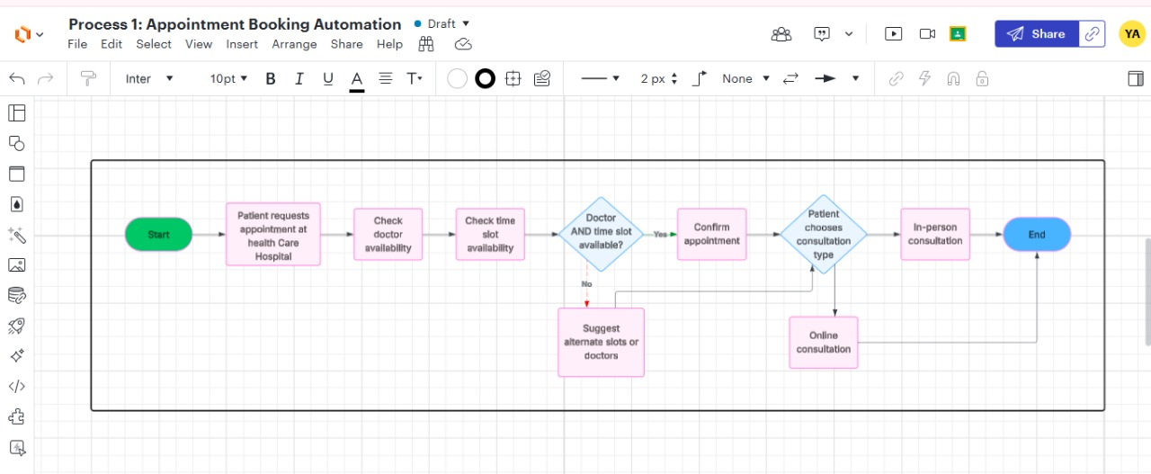
2. Patient Admission Automation
Process Statement:
When a patient arrives at the hospital, the system checks whether it is an emergency XOR scheduled admission—only one can apply.
Then, the system verifies bed/room availability and insurance validity.
If both conditions are met, the patient is admitted.
If either the bed is unavailable or the insurance is invalid, the system places the patient on a waiting list or redirects to a partner hospital.
https://lucid.app/lucidchart/f553cce7-271f-40bd-95f5-dc9148c903a3/edit?viewport_loc=-303%2C533%2C1767%2C625%2CDcrdctHPzXOG&invitationId=inv_fc44609e-1a04-4078-928c-b89b19dc4597

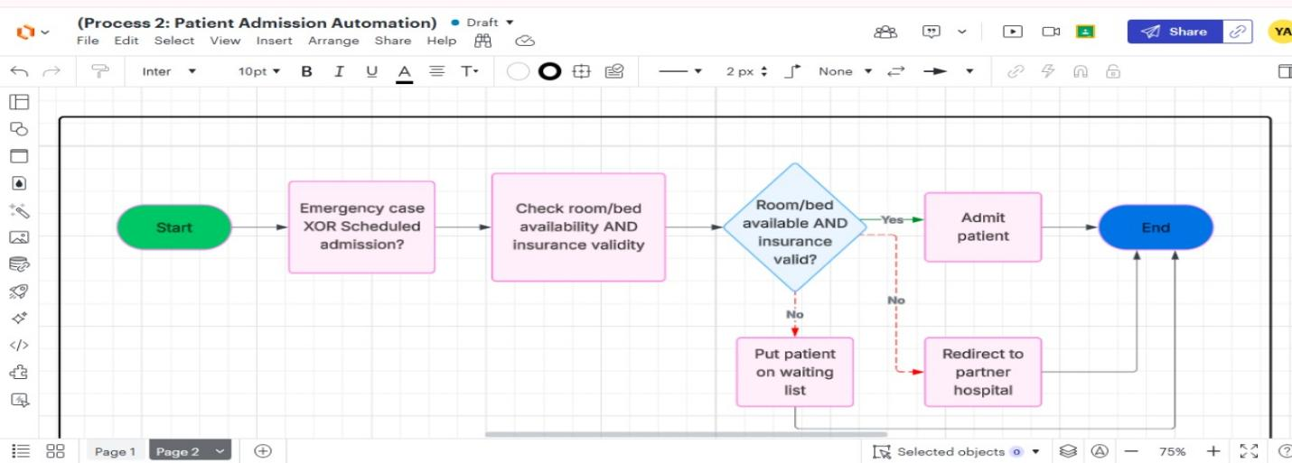

❌ Processes Not Yet Automated
1. Doctor’s Consultation Process (Currently Manual)
Currently, the doctor’s consultation process is conducted manually. The doctor checks symptoms and provides a diagnosis/prescription without system integration.
📌 Proposed Automation Statement:
When a patient requests a consultation, the system collects the patient’s medical history and symptoms.
If an online consultation is requested, the system schedules it through a telemedicine platform.
If in-person consultation is preferred, the system checks for doctor and slot availability.
If available, the consultation is scheduled.
After the consultation, the system records the diagnosis and prescription and shares it with the patient.
https://lucid.app/lucidchart/f553cce7-271f-40bd-95f5-dc9148c903a3/edit?viewport_loc=-672%2C-904%2C2650%2C938%2CLprdr-X9SQwX&invitationId=inv_fc44609e-1a04-4078-928c-b89b19dc4597

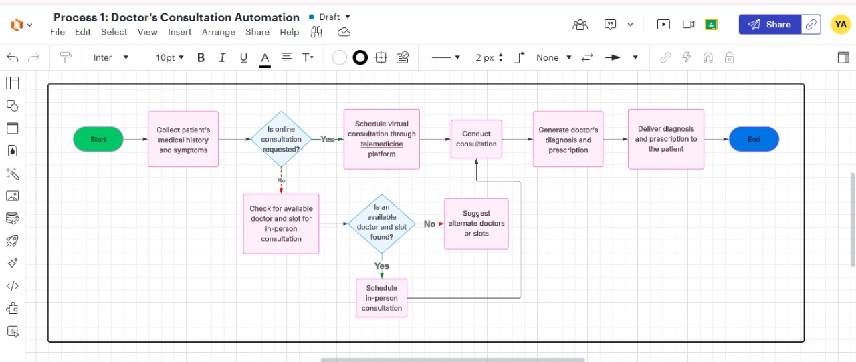

2. Billing and Payment Process (Currently Manual)
The billing is currently done manually after treatment, and payments are processed at the front desk. Insurance is also verified manually.
📌 Proposed Automation Statement:
Once the treatment is completed, the system automatically calculates and generates the bill based on treatment details.
It then verifies the patient’s insurance details.
If valid, the system applies any applicable discounts or insurance coverage.
The system displays available online payment options (e.g., credit card, wallet, bank transfer).
If the payment is completed, a confirmation is sent, and the patient's record is updated.
If payment is incomplete, the system sends a reminder to the patient.
https://lucid.app/lucidchart/f553cce7-271f-40bd-95f5-dc9148c903a3/edit?viewport_loc=-764%2C-814%2C2650%2C938%2CCvrdQfZ0jLXV&invitationId=inv_fc44609e-1a04-4078-928c-b89b19dc4597

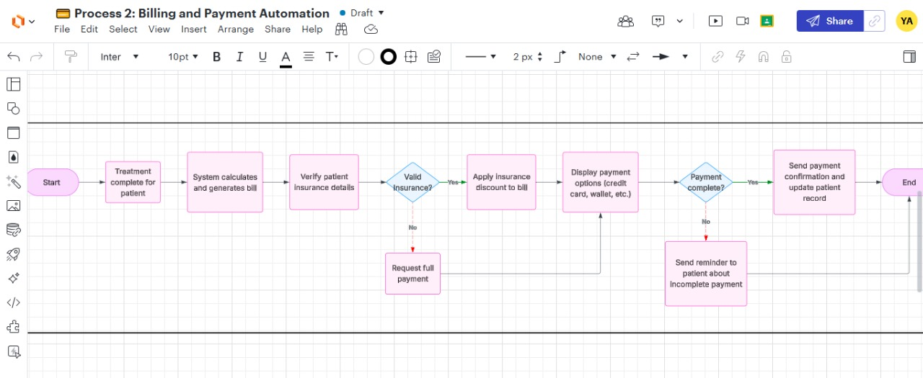
🛠️ Recommendations
- Implement an AI-supported telemedicine system to automate doctor's consultations for online patients.
- Introduce a robust hospital billing system integrated with insurance verification and online payment gateways.
- Develop flowcharts based on the proposed statements to guide system design and implementation teams.
📌 Conclusion
HealthCare Hospital & Diagnostics has made significant progress by automating key processes such as appointment booking and patient admission. However, doctor’s consultation and billing/payment processing remain manual and require automation to improve efficiency, accuracy, and patient experience.

